GAMR3531 Report Template
Repo URL: | https://github.com/GAMR3531/cw26-beani3/tree/LODs |  |  |  | Commit: | 70705a15e6766d99cbc80e821757c82b2c5fc83b
Tick all parts of the submission that this report covers:
GPU | Profile run and documented but no changes made. | All redundant binding of GPU buffers and shaders removed. Profile run and documented for this change. | Successfully Implement either a depth-pre pass or move to deferred or tiled rendering. Profile run and documented. | Successfully Implemented a LOD scheme. Profile run and documented. | Successfully Implemented instanced rendering. Profile run and documented. | Rewrite the Bloom effect in compute shaders or GPU side frustum culling in a compute shader.  Profile run and documented. | Innovation beyond the specification.
 | ☐ | ☐ | ☐ | ☐ | ☐ | ☐ | ☐
CPU | Profile run and documented but no changes made. | Replace polymorphic games object with composable game objects.  Profile run and documented. | Minimised memory footprint of all classes.  Improve memory use of UBO/UBOManager. Profile run and documented. | Successfully implemented SIMD collision checks (beyond default/GLM optimisation) or CPU side frustum culling.  Profile run and documented. | Successfully Implemented a spatial partitioning scheme for broad phase collision checks. Profile run and documented. | Manually manage all RAM allocations with a sensible scheme.  Profile run and documented. | Innovation beyond the specification.
 | ☐ | ☐ | ☐ | ☐ | ☐ | ☐ | ☐
What change(s) have you made: |  | Implemented LODs.
Which tools have you used to provide evidence for the change(s) you have made? |  | ☐ | Tracy
 |  | ☐ | RenderDoc/NSight
 |  | ☐ | Custom instrumentation
 |  | ☐ | Other (please state)
Put your Evidence here: |  | 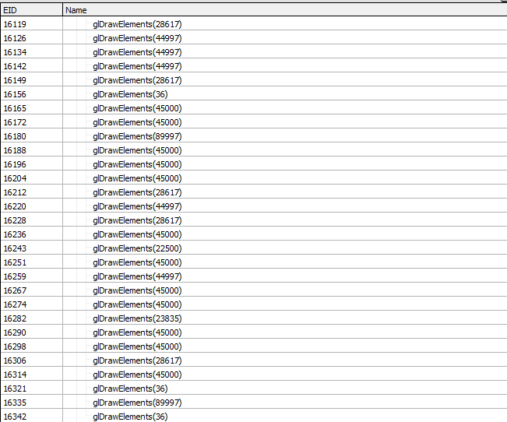  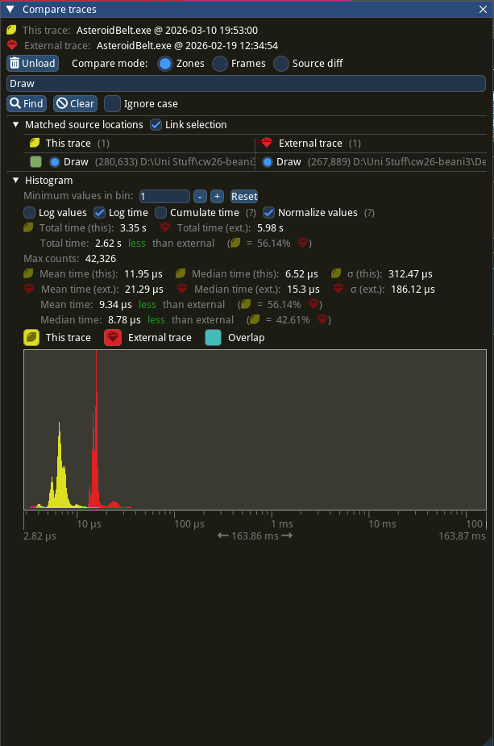  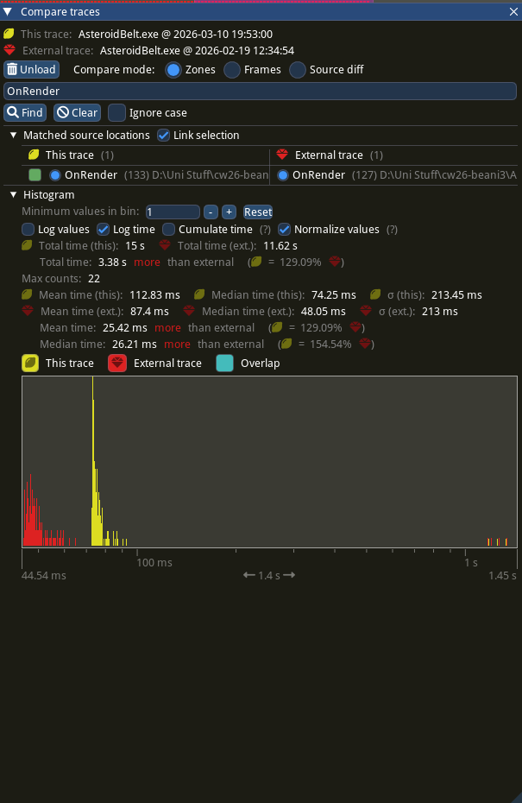  Figure 1: Draw call comparison. LODs (Yellow) and Redundant Binds (Red)  Figure 2: OnRender() comparison. LODs (Yellow) and Redundant Binds (Red)  Figure 3: RenderDoc draw calls
Anything else you want to add? |  | Implementing LODs has greatly improved performance due to reducing draw calls. This is evidenced in Figure 1 and Figure 3. However, LODs has had a negative impact on OnRender(), Figure 3, which makes sense given some of its implementation is done in renderer.cpp. One final thing to note that hasn’t been documented is that the project loads significantly faster since adding LODs.

